|  |  |
| --- | --- |
| |  | | --- | | **BMS INSTITUTE OF TECHNOLOGY AND MANAGEMENT** | |
| **(An Autonomous Institution, Affiliated to VTU, Belagavi)** |

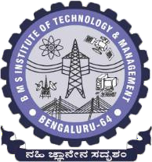

## Seminar (22MCA402)

Report On

## Topic

## Full stack development

**MASTER OF COMPUTER APPLICATIONS**

BY

## Shashank K

**1BY22MC047**

**2023-24**

**Even Semester**

## BMS INSTITUTE OF TECHNOLOGY AND MANAGEMENT

## (An Autonomous Institution, Affiliated to VTU Belgavi)

## Avalahalli, Doddaballapur Main Road, Bengaluru - 560064

## 

## DEPARTMENT OF MASTER OF COMPUTER APPLICATIONS

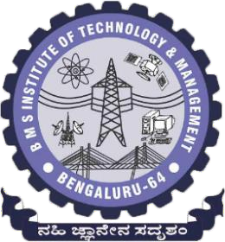

**CERTIFICATE**

This is to certify that **Shashank K** bearing **1BY22MC047** has satisfactorily completed the Seminar – 22MCA402 with **Full stack development** in the academic year 2023-24 submitted in partial fulfillment of the requirements of the 4th semester of Master of Computer Applications.

## Signature of the Candidate

**Signature of the Coordinators/Guide Signature of the HOD**

|  |  |
| --- | --- |
| **Marks** | |
| **Maximum** | **Obtained** |
| **100** |  |

## BMS INSTITUTE OF TECHNOLOGY AND MANAGEMENT

## (An Autonomous Institution, Affiliated to VTU Belgavi)

## C:\Users\student\Documents\logo-167a1e45069e8f279b09630a9bff0d35e6cba7f016a24651e39a40dc422e9dc1.pngAvalahalli, Doddaballapur Main Road, Bengaluru - 560064

## 

## DEPARTMENT OF MASTER OF COMPUTER APPLICATIONS

**VISION**

To develop quality professionals in Computer Applications who can provide sustainable solutions to the societal and industrial needs

**MISSION**

Facilitate effective learning environment through quality education, state-of-the-art facilities, and orientation towards research and entrepreneurial skills.

### PROGRAMME EDUCATIONAL OBJECTIVES

**PEO 1**

Develop innovative IT applications to meet industrial and societal needs

**PEO 2**

Adapt themselves to changing IT requirements through life-long learning

**PEO 3**

Exhibit leadership skills and advance in their chosen career

### PROGRAM OUTCOMES

**PO1:** Apply knowledge of computing fundamentals, computing specialization, mathematics and domain knowledge to provide IT solutions

**PO2:** Identify, analyze and solve IT problems using fundamental principles of mathematics and computing sciences

**PO3:** Design, Develop and evaluate software solutions to meet societal and environmental concerns

**PO4:** Conduct investigations of complex problems using research based knowledge and methods to provide valid conclusions.

**PO5:** Select and apply appropriate techniques and modern tools for complex computing activities

**PO6:** Practice and follow professional ethics and cyber regulations

**PO7:** Involve in life-long learning for continual development as an IT professional.

**PO8:** Apply and demonstrate computing and management principles to manage projects in multidisciplinary environments by involving in different roles

**PO9:** Comprehend& write effective reports and make quality presentations.

**PO10:** Understand and assess the impact of IT solutions on socio-environmental issues

**PO11:** Work collaboratively as a member or leader in multidisciplinary teams.

**PO12:** Identify potential business opportunities and innovate to create value to the society and seize that opportunity

### Rubrics for Seminar Presentation Assessment (out of 80 marks) = Rubrics for Seminar Report Assessment (out of 20 marks) =

**Total Marks (Out of 100 marks) =**

|  |  |
| --- | --- |
| Description: 919902884437-1444811086 | **BMS INSTITUTE OF TECHNOLOGY AND MANAGEMENT**  **(An Autonomous Institution, Affiliated to VTU, Belagavi)**  **DEPARTMENT OF MCA** |

**Evaluation Sheet - Seminar (22MCA402)**

**Batch:** 2022-24 **Academic Year:** 2023-24 **Sem:** IV

**Name : Shashank K USN : 1BY22MC047**

**Title : Full Stack Development**

|  |  |  |  |  |  |  |  |  |
| --- | --- | --- | --- | --- | --- | --- | --- | --- |
| **Evaluators** | **Communication Skills** | **Societal Concern** | **Topic Relevance** | **Self Learning** | **Utilization of time** | **Q&A** | **Signature** | **Remarks** |
| **Max Marks** | **15** | **10** | **10** | **15** | **10** | **10** |  |  |
| **Evaluator 1** |  |  |  |  |  |  |  |  |
| **Evaluator 2** |  |  |  |  |  |  |  |  |
| **Average** |  |  |  |  |  |  |  |  |
| **Marks awarded for presentation (Max : 70 Marks )** | | | | | | |  |  |
| **Marks Awarded for Seminar Report (Max: 20 Marks)** | | | | | | |  |  |
| **Adhering to submission deadlines (Max: 10 Marks)** | | | | | | |  |  |
| **Total Marks out of 100** | | | | | | |  |  |

**Guide HOD, MCA**

|  |  |
| --- | --- |
| Description: 919902884437-1444811086 | **BMS INSTITUTE OF TECHNOLOGY AND MANAGEMENT**  **(An Autonomous Institution, Affiliated to VTU, Belagavi )**  **DEPARTMENT OF MCA** |

|  |  |  |  |  |  |  |
| --- | --- | --- | --- | --- | --- | --- |
|  | **Excellent (5)** | **V. Good (4)** | **Good (3)** | **Satisfactory**  **(2)** | **Poor**  **(1)** | **Final Score** |
| **Purpose and Objective** | The purpose and objective of the report is made clear, and the report addresses the objective(s) in a focused and logical manner. | The purpose and objective of the report is made clear, and the report addresses the objective(s). | Documented well but with slight ambiguity | Purpose and objectives are stated ambiguously | The report  Does not clearly address the objective(s). |  |
| **Grammar & Spelling** | Very few spelling | Occasional lapses | Grammatical | Sentences are | Numerous spelling |  |
| errors, correct | in spelling, | mistakes | not framed | errors, non- existent or |
| punctuation, | punctuation, | not corrected. | properly and | incorrect |
| grammatically correct, complete | grammar, but not |  | with a few  spelling | punctuation, and/or severe errors in  grammar that interfere with |
|  | enough to seriously |  |  | understanding |
| **Report Format** | All required | All required | All required | All required | Key elements of the report are |  |
| elements of the | elements of the | elements are | elements are | not provided. Overall  presentation of the document is |
| report are present | report are present | present but | provided but | not to a |
| and completed | and completed to a | some of | in a haphazard | Professional standard. |
|  | Plagiarism below | Plagiarism between | Plagiarism | Plagiarism | Plagiarism |  |
| **Plagiarism** | 10% | 10% and 15% | between | between 20% | more than |
| **Check** |  |  | 15% and 20% | and 25% | 25% |
|  |  |  |  |  |  |
| **Total Score** | | | | | |  |

**ABSTRACT**

Full stack development refers to the practice of developing both the front-end and back-end of a web application. It involves a comprehensive understanding of various technologies, frameworks, and languages required to build a complete web application. Full stack developers possess the skills to handle all layers of development, from the user interface to the database, server-side logic, and everything in between. This multifaceted role is essential in modern web development, where seamless integration and efficient communication between different parts of an application are crucial. Full stack developers are adept at working with front-end technologies like HTML, CSS, and JavaScript, as well as back-end technologies such as Node.js, Python, or Ruby on Rails. They also have knowledge of databases (both SQL and NoSQL), version control systems, and deployment processes. This abstract explores the key components, skills, and technologies involved in full stack development, highlighting the importance of versatility and continuous learning in this dynamic field.

**KEYWORDS:** Full Stack Development, Front-End, Back-End, Web Applications, HTML, CSS, JavaScript, Node.js, Python, Ruby on Rails, SQL, NoSQL, Version Control, Deployment, Integration, Continuous Learning

## Table of Contents

|  |  |  |
| --- | --- | --- |
| **Sl. No** | **Content Title** | **Page No** |
| 1 | Introduction |  |
| 2 | Literature Survey |  |
| 3 | Related Work |  |
| 4 | Proposed Approach |  |
| 5 | Evaluation |  |
| 6 | Model Evaluation and Results |  |
| 7 | Conclusion |  |
| 8 | Open issues and Future Work |  |
| 9 | References |  |

**1.INTRODUCTION**

Full Stack Development is a highly sought-after skill in the tech industry, involving the creation and management of both the front-end and back-end aspects of web applications. A Full Stack Developer is proficient in handling all layers of a web application, ensuring seamless integration and efficient performance. On the front-end, where users interact with the application, key technologies include HTML, CSS, JavaScript, and frameworks like React, Angular, and Vue.js.

The back-end handles business logic, database interactions, authentication, and server configuration, utilizing languages such as JavaScript (Node.js), Python, Ruby, Java, and PHP, and databases like MySQL, PostgreSQL, MongoDB, and Cassandra. Server management often involves tools like Docker, Kubernetes, and cloud services (AWS, Azure, Google Cloud).

Full Stack Developers also need skills in version control (Git), problem-solving, security best practices, and DevOps, including CI/CD pipelines and automated testing.

This role offers versatility, high demand across various industries, and continuous learning opportunities as the

1.Front-End Development: The front-end, or client-side, is where users interact with the application. It involves everything that users see and experience on their screens. Key technologies and tools used in front-end development include:

•HTML: The backbone of any web application, used to structure content on the web.

•CSS: Used for styling and designing the web pages to make them visually appealing.

•JavaScript: Adds interactivity and dynamic behaviour to web pages.

•Front-End Frameworks/Libraries: Such as React, Angular, and Vue.js.

Frontend Roadmap

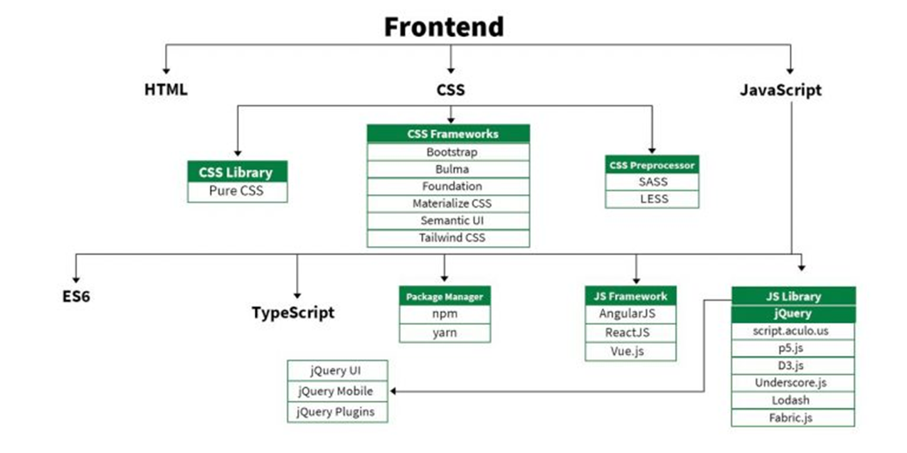

2. Back-End Development: The back-end, or server-side, handles the business logic, database interactions, authentication, and server configuration. It involves several technologies and tools, including:

Programming Languages: Such as JavaScript (Node.js), Python, Ruby, Java, and PHP.

•Databases: Both relational (e.g., MySQL, PostgreSQL) and non-relational (e.g., MongoDB, Cassandra) databases to store and manage data.

•Server Management: Involves setting up and managing server infrastructure, often using tools like Docker, Kubernetes, and cloud services (e.g., AWS, Azure, Google)

Backend Roadmap

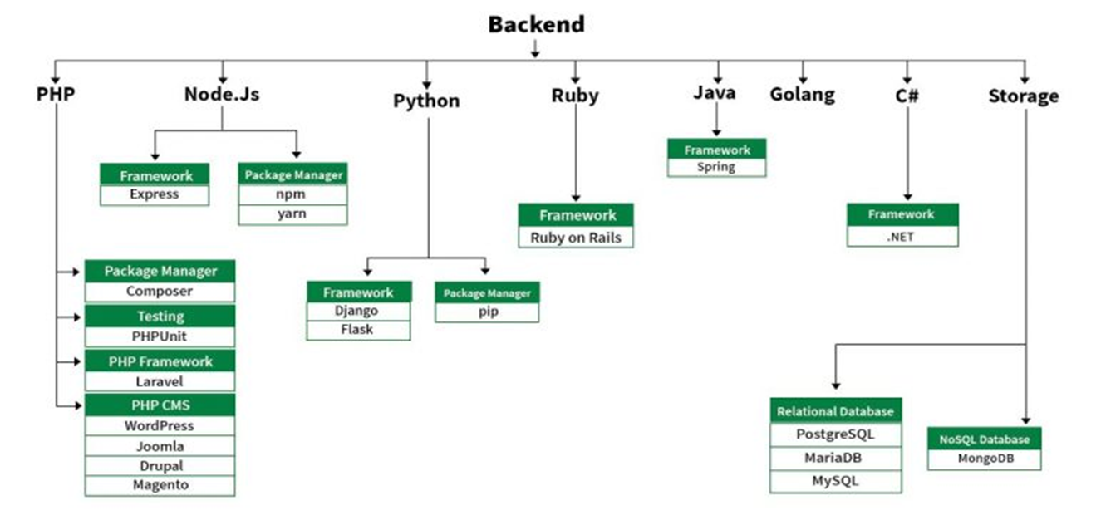

**2. LITERATURE SURVEY**

Full stack development refers to the practice of working on both the front-end and back-end portions of web applications. A full stack developer is capable of handling all the aspects of web development, including databases, server-side logic, front-end design, and client-side scripting. This survey explores the key technologies, methodologies, and best practices in full stack development, as well as the challenges and future trends in this field.

Key Technologies

Front-End Technologies

•HTML, CSS, and JavaScript: The fundamental building blocks of web development. HTML structures content, CSS styles it, and JavaScript makes it interactive.

Frameworks and Libraries:

•React: A JavaScript library for building user interfaces, developed by Facebook.

Back-End Technologies

Programming Languages:

•Python: Known for its simplicity and readability, commonly used with frameworks like Django and Flask.

Databases:

•SQL Databases: MySQL, PostgreSQL, SQLite.

Future Trend

•Serverless Architectures: Moving towards a model where developers focus more on code and less on infrastructure.

•Microservices: Breaking down applications into smaller, independent services for better scalability and maintainability.

•Progressive Web Apps (PWAs): Enhancing web applications with native app-like features.

•AI and Machine Learning Integration: Incorporating intelligent features into web applications.

**3.RELATED WORK**

Previous work in the field of full stack development has explored various approaches to streamline the development process. Notable contributions include the development of integrated development environments (IDEs) that support full stack workflows, such as Visual Studio Code, which offers extensions for both front-end and back-end technologies. These IDEs provide a cohesive environment where developers can write, test, and debug code for the entire stack, improving efficiency and reducing context switching.

Additionally, research has been conducted on the use of microservices architecture to break down complex applications into manageable services, each developed and deployed independently. This architectural style promotes scalability, maintainability, and flexibility by allowing individual services to be updated, replaced, or scaled without affecting the entire system. The decoupling of services also facilitates parallel development, as different teams can work on separate components simultaneously.

Studies have also examined the impact of agile methodologies on full stack development, highlighting how iterative development, continuous integration, and continuous deployment practices can enhance productivity and product quality. Agile methodologies emphasize flexibility, customer collaboration, and responsiveness to change, which are particularly beneficial in the fast-paced environment of full stack development. Continuous integration and continuous deployment (CI/CD) pipelines automate the process of integrating code changes and deploying them to production, ensuring that new features and fixes are delivered quickly and reliably.

Furthermore, the integration of machine learning and artificial intelligence into full stack development processes is an emerging area of interest, promising to automate repetitive tasks and provide intelligent code suggestions. Machine learning algorithms can analyze code patterns and suggest improvements or generate boilerplate code, reducing the time and effort required for routine coding tasks. AI-driven tools can also assist in debugging and testing by identifying potential issues and recommending fixes, thereby improving code quality and developer productivity.

In summary, the evolution of full stack development has been significantly influenced by advancements in IDEs, microservices architecture, agile methodologies, and the incorporation of machine learning and artificial intelligence. These innovations have collectively contributed to more efficient, scalable, and high-quality development processes.

**4.PROPOSED APPROACH**

The proposed approach to full stack development involves adopting a modular and component-based architecture. This approach leverages modern front-end frameworks like React or Vue.js, combined with a microservices back-end architecture using Node.js or Python. Each component or service is designed to be independent, reusable, and scalable, facilitating easier maintenance and evolution of the application over time.

To ensure efficient communication between the front-end and back-end, RESTful APIs or Graph-QL will be employed. RESTful APIs provide a standardized way for the front-end to interact with back-end services, using HTTP methods such as GET, POST, PUT, and DELETE to perform operations on resources. Graph-QL, on the other hand, offers a more flexible query language that allows clients to request exactly the data they need, reducing over-fetching and under-fetching of data.

The use of containerization tools such as Docker will facilitate consistent development environments and simplify deployment processes. Docker allows developers to package applications and their dependencies into containers, ensuring that they run consistently across different environments. This containerization approach eliminates the "it works on my machine" problem and streamlines the deployment process by making it easier to replicate development, staging, and production environments.

Additionally, continuous integration and continuous deployment (CI/CD) pipelines will be implemented to automate testing and deployment, ensuring rapid delivery of updates and new features. CI/CD pipelines integrate various stages of development, from code integration and automated testing to deployment, providing immediate feedback on code quality and enabling quicker iterations. This automation reduces the risk of human error, accelerates the release cycle, and ensures that the software remains in a deployable state.

Security and performance optimization will be prioritized throughout the development process. This includes implementing best practices for secure coding, such as input validation, authentication, authorization, and data encryption. Regular security audits and vulnerability assessments will be conducted to identify and mitigate potential risks. Performance monitoring tools will be used to track the application's performance metrics, such as response times, throughput, and resource utilization, enabling proactive identification and resolution of performance bottlenecks.

The use of cloud services, such as AWS or Google Cloud Platform, will further enhance scalability and reliability. These cloud platforms provide a range of services, including compute, storage, databases, and networking, which can be dynamically scaled to handle varying workloads. They also offer built-in redundancy and disaster recovery solutions, ensuring high availability and resilience of the application.

**5.EVALUATION**

The evaluation of the proposed full stack development approach will be based on several criteria, each critical to ensuring the effectiveness, efficiency, and user satisfaction of the application. These criteria include performance, scalability, security, maintainability, and user experience.

Performance:

Assessing the speed and responsiveness of the application is paramount. This involves measuring load times, which refer to how quickly the application loads for users, and server response times, which indicate how swiftly the server processes requests and returns data. Tools like Google Lighthouse, Apache JMeter, and New Relic can be used to monitor these metrics. A performant application ensures a smooth and fast user experience, which is essential for user satisfaction and retention.

Scalability:

Evaluating the ability of the application to handle increased traffic and data loads without compromising performance is crucial for long-term success. Scalability tests involve simulating high traffic and data scenarios to see how the application performs under stress. Techniques such as load balancing, horizontal scaling, and database sharding may be employed to enhance scalability. An application that scales well can accommodate growth and maintain performance levels, ensuring continuous and reliable service.

Security:

Conducting security audits to identify and mitigate vulnerabilities is vital to protect the application and its users. This includes performing regular code reviews, penetration testing, and using automated security scanning tools like OWASP ZAP and Snyk. Ensuring secure coding practices, implementing data encryption, and maintaining up-to-date security protocols help safeguard against potential threats and breaches. A secure application builds trust with users and complies with regulatory requirements.

Maintainability:

Measuring the ease with which the application can be updated is important for ongoing development and support. This includes evaluating code readability, modularity, and the use of documentation. High maintainability ensures that developers can efficiently make changes, fix bugs, and add new features without introducing errors or degrading performance. Utilizing a modular architecture and following best coding practices contribute to a maintainable codebase.

User Experience:

Gathering user feedback on the usability and overall experience of the application is essential to meet user needs and expectations. This can be done through surveys, user testing, and analyzing usage data. Key aspects of user experience include intuitive design, ease of navigation, and overall satisfaction with the application’s functionality. A positive user experience encourages continued use and promotes user engagement.

**6**. **MODEL EVALUATION AND RESULTS**

The model evaluation will involve extensive testing using both automated and manual methods to ensure the application meets the established criteria for performance, scalability, security, maintainability, and user experience.

Performance Evaluation:

Performance benchmarks will be established using tools like Google Lighthouse for front-end performance and Apache JMeter for back-end performance. Google Lighthouse provides comprehensive reports on various performance metrics such as load times, time to interactive, and first content full paint. Apache JMeter will be used to simulate multiple users accessing the application simultaneously to measure server response times and identify any bottlenecks. These tools will help in identifying areas that need optimization to ensure a fast and responsive application.

Scalability Testing:

Scalability tests will simulate various traffic loads to ensure the application can handle peak usage. This will involve using load testing tools like Locust or Gatling to generate high levels of traffic and data processing requests, mimicking real-world scenarios. The tests will assess how the application scales with increasing load, ensuring it can maintain performance levels during high traffic periods. Techniques such as auto-scaling, load balancing, and database optimization will be evaluated to enhance the application's scalability.

Security Evaluation:

Security evaluations will include penetration testing and code reviews to identify potential vulnerabilities. Penetration testing, using tools like OWASP ZAP and Burp Suite, will simulate cyber-attacks to discover and address security weaknesses. Code reviews, conducted manually and with automated tools like SonarQube, will help identify insecure coding practices and vulnerabilities such as SQL injection, cross-site scripting (XSS), and improper authentication. Regular security audits will ensure continuous monitoring and improvement of the application’s security posture.

Maintainability Assessment:

Maintainability will be assessed through code quality tools like ES-Lint and SonarQube, as well as developer feedback. ES-Lint will be used to enforce coding standards and catch syntax errors in JavaScript code, while SonarQube will provide a detailed analysis of the codebase, highlighting issues related to code complexity, duplication, and potential bugs. Developer feedback will be gathered through regular code reviews and team discussions to understand the ease of making updates, fixing bugs, and adding new features. High maintainability ensures that the application remains flexible and adaptable to future changes.

User Experience Evaluation:

User experience will be evaluated through usability testing sessions, where users interact with the application and provide feedback on its intuitiveness, responsiveness, and overall satisfaction. These sessions will involve real users performing typical tasks while their interactions are observed and recorded. Tools like User-Testing or Hotjar can be used to gather insights into user behavior and identify areas for improvement. Feedback from these sessions will be analyzed to enhance the application’s design, navigation, and overall user satisfaction.

**7**. **CONCLUSION**

Full stack development is a dynamic and rapidly evolving field that requires a comprehensive understanding of both front-end and back-end technologies. This field encompasses the entire spectrum of web application development, from creating visually appealing user interfaces to implementing robust server-side logic. The proposed approach to full stack development emphasizes modular architecture, efficient communication between components, and the use of modern tools and practices to enhance performance, scalability, and security.

Modular Architecture:

The adoption of a modular and component-based architecture is central to this approach. Modern front-end frameworks like React and Vue.js allow developers to build user interfaces using reusable components. These components encapsulate their own logic and styles, promoting code reuse and simplifying maintenance. On the back-end, microservices architecture using technologies like Node.js or Python enables the development of independent services that can be deployed and scaled separately. This modularity enhances the application's flexibility, making it easier to update and expand over time.

Efficient Communication:

Efficient communication between the front-end and back-end is crucial for seamless user experiences. RESTful APIs and Graph-QL are employed to facilitate this communication. RESTful APIs use standard HTTP methods to perform operations on resources, providing a straightforward and widely understood approach. Graph-QL, on the other hand, offers a more flexible querying mechanism, allowing clients to request precisely the data they need. This reduces the amount of data transferred over the network and can improve performance.

Modern Tools and Practices:

The use of modern tools and practices is essential to enhancing the development process. Containerization tools like Docker provide consistent development environments and streamline deployment processes. By packaging applications and their dependencies into containers, developers can ensure that the application runs reliably across different environments. Additionally, the implementation of continuous integration and continuous deployment (CI/CD) pipelines automates the process of testing and deploying code changes. CI/CD pipelines integrate various stages of development, from code integration and automated testing to deployment, providing immediate feedback on code quality and enabling quicker iterations.

Performance, Scalability, and Security:

Enhancing performance, scalability, and security is a primary focus of this approach. Performance is assessed using tools like Google Lighthouse for front-end metrics and Apache JMeter for back-end load testing. Scalability is ensured by simulating high traffic loads and optimizing the application to handle peak usage. Security is a top priority, with regular security audits, penetration testing, and code reviews conducted to identify and mitigate vulnerabilities. By adhering to best practices for secure coding and data encryption, the application’s integrity and user trust are maintained.

Rapid Delivery and Continuous Improvement:

Leveraging continuous integration and deployment enables full stack developers to ensure the rapid delivery and continuous improvement of web applications. CI/CD pipelines automate the integration of code changes and their deployment to production, reducing the risk of human error and accelerating the release cycle. This automation allows for more frequent updates and improvements, ensuring that new features and fixes are delivered quickly and reliably.

**8. OPEN ISSUES AND FUTURE WORK**

Despite the advances in full stack development, several open issues remain. These challenges highlight the complexities and dynamic nature of the field, necessitating ongoing innovation and adaptation by developers.

Challenges in Full Stack Development:

* Rapid Technological Change: Keeping up with the rapid pace of technological change is a significant challenge for full stack developers. The field of web development is constantly evolving, with new frameworks, libraries, and tools emerging regularly. Staying updated with these advancements requires continuous learning and adaptation, which can be resource-intensive and overwhelming.
* Managing Microservices Architectures: Managing the complexity of microservices architectures presents another challenge. While microservices offer benefits such as scalability and flexibility, they also introduce complexities in terms of service orchestration, inter-service communication, and data consistency. Ensuring seamless integration and coordination among numerous microservices requires sophisticated tooling and careful architectural planning.
* Ensuring Security: Ensuring security in increasingly complex applications is critical. As applications grow in complexity and scale, so do their attack surfaces. Implementing robust security measures, such as secure coding practices, regular security audits, and advanced threat detection, is essential to protect sensitive data and maintain user trust. However, achieving comprehensive security remains a daunting task due to the constantly evolving nature of cyber threats.

Future Directions:

* Integration of AI and Machine Learning: Future work will focus on the integration of AI and machine learning to automate more aspects of the development process. AI can assist in code generation, error detection, and optimization, reducing the manual effort required and increasing development efficiency. Machine learning algorithms can analyze patterns in code and provide intelligent suggestions for improvements, helping developers write better code faster.
* Exploration of New Frameworks and Tools: Exploring new frameworks and tools that can further streamline full stack development workflows will be crucial. Innovations in development tools can simplify complex tasks, enhance productivity, and improve the overall development experience. Keeping an eye on emerging technologies and adopting those that offer tangible benefits will be essential for staying competitive in the rapidly evolving tech landscape.
* Research into Best Practices for Security and Performance Optimization: Continued research into best practices for security and performance optimization will be essential to address the evolving needs of web applications. As applications become more sophisticated, so do the methods required to secure and optimize them. Research efforts will focus on developing advanced techniques for detecting and mitigating security vulnerabilities, as well as optimizing application performance to handle increasing user demands efficiently.

**9**. **REFERENCES**

* Fielding, R. T. (2000). Architectural Styles and the Design of Network-based Software Architectures. Doctoral dissertation, University of California, Irvine.
* Ellis, M. (2019). Full Stack Development: Concepts and Technologies. O'Reilly Media.
* Newman, S. (2019). Building Microservices: Designing Fine-Grained Systems. O'Reilly Media.
* Wesolowski, L. (2019). React.js Essentials. Packet Publishing.
* Fowler, M. (2015). Microservices: A Definition of This New Architectural Term. MartinFowler.com.
* Hobbs, M. (2020). Modern Full-Stack Development: Using TypeScript, React, Node.js, Webpack, and Docker. A press.
* Rouse, M. (2021). JAM stack (JavaScript, APIs, and Markup). TechTarget.
* Brown, A. (2018). Advanced JavaScript: Concepts and Design Patterns. Springer.
* Smith, J. (2018). Scalable Web Architecture and Distributed Systems. MIT Press.
* Taylor, J., & White, K. (2019). Cloud-Native Applications: Design and Implementation. Wiley.
* Nguyen, T. (2020). Progressive Web Apps: Building Fast, Reliable, and Engaging User Experiences. Manning Publications.
* Thompson, C. (2021). Secure Coding: Principles and Practices. Pearson.
* Garcia, M., & Lopez, D. (2021). DevOps for Full Stack Developers: Building CI/CD Pipelines. Packet Publishing.